This post was published to Code Blog at 11:02:00 AM 11/10/2016

Targeting Web Transformations during VSTS Build

Category VSTS ; .NET

## ​We can utilize web.config transforms to apply specific settings based on the application environment we are building for (Dev, Test, Release).

* A common use case is to provide a different database connection string for each environment.

### Add a new configuration

### Provide configuration name and settings

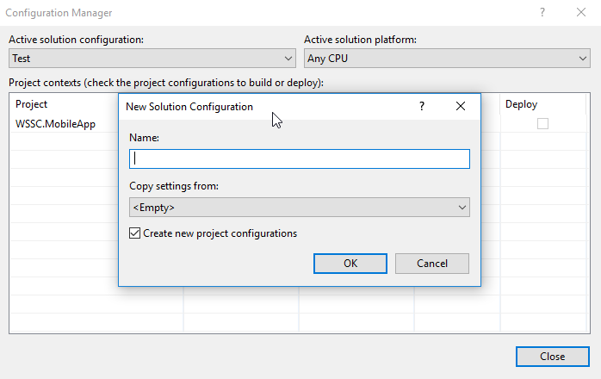

### Right click on the web.config file for your asp.net app, select 'Add Config Transform'

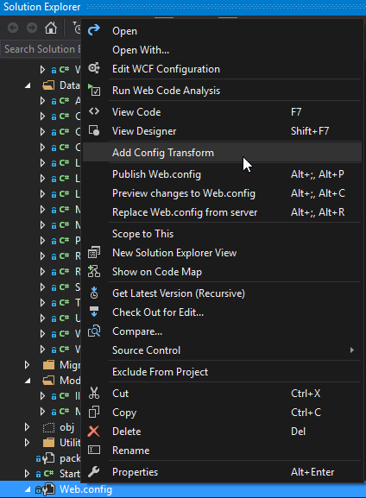

### The generated .config files represent the transformations we can apply for each build configuration.

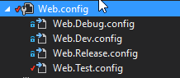

### The following is a transform applied during a 'Test' build configuration.

### Here, we change the RedirectUri to point to our application instance on Test.

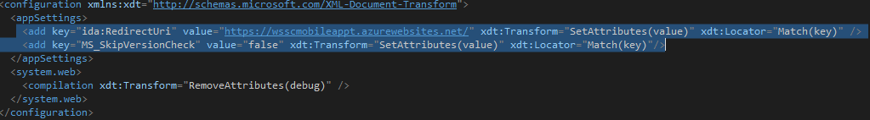

### Finally, in your VSTS Build Definition, navigate to the 'Variables' tab.

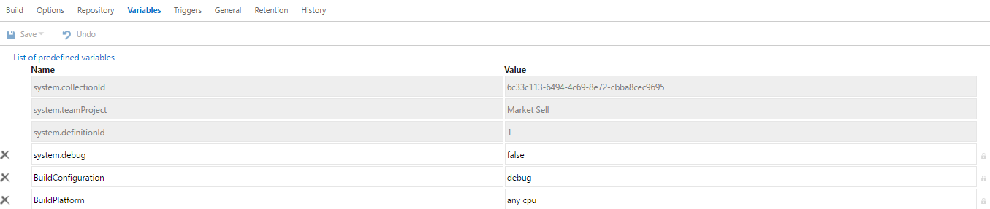

### To target a specific web configuration, provide the corresponding value for the 'BuildConfiguration' field.